Packet Tracer Multiuser - Implement Services (Instructor Version – Optional Packet Tracer)

**Instructor Note**: Red font color or gray highlights indicate text that appears in the instructor copy only. Optional activities are designed to enhance understanding and/or to provide additional practice.

1. Topology

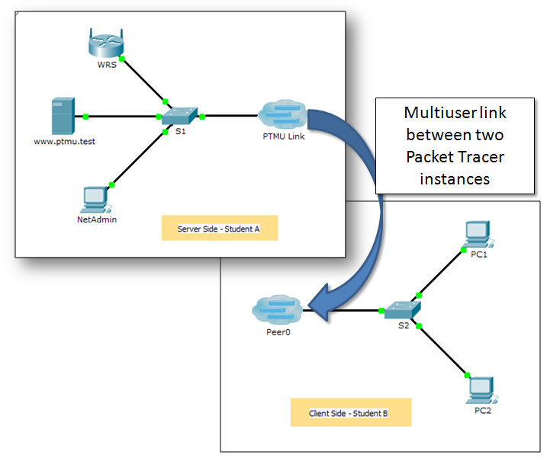

1. Addressing Table

|  |  |  |
| --- | --- | --- |
| Device | IP Address | Subnet Mask |
| **Server Side Player** | | |
| WRS | 172.16.1.254 | 255.255.255.0 |
| S1 | 172.16.1.1 | 255.255.255.0 |
| www.ptmu.test | 172.16.1.5 | 255.255.255.0 |
| NetAdmin | DHCP Assigned | DHCP Assigned |
| **Client Side Player** | | |
| S2 | 172.16.1.2 | 255.255.255.0 |
| PC1 | DHCP Assigned | DHCP Assigned |
| PC2 | DHCP Assigned | DHCP Assigned |

Objectives

Part 1: Establish a Local Multiuser Connection to another Instance of Packet Tracer

Part 2: Server Side Player - Implement and Verify Services

Part 3: Client Side Player - Configure and Verify Access to Services

1. Background

**Note:** Completing the prior activities in this chapter, including the **Packet Tracer Multiuser - Tutorial**, are prerequisites to completing this activity.

In this multiuser activity, two students (players) cooperate to implement and verify services including DHCP, HTTP, Email, DNS, and FTP. The server side player will implement and verify services on one server. The client side player will configure two clients and verify access to services.

1. Establish a Local Multiuser Connection to Another Instance of Packet Tracer
   1. Select a partner and determine the role for each student.
      1. Find a fellow classmate with whom you will cooperate to complete this activity. Your computers must both be connected to the same LAN.
      2. Determine which of you will play the server side and which of you will play the client side in this activity.
   2. The server side player opens **Packet Tracer Multiuser - Implement Services - Server Side.pka**.
   3. The client side player opens **Packet Tracer Multiuser - Implement Services - Client Side.pka**.

**Note:** Solo players can open both files and complete the steps for both sides.

* 1. Configure the switches with initial configurations.

Each player: configure your respective switch with the following:

1. Hostname using the name in the addressing tables. (**S1** for the switch in the Server Side Player or **S2** for the switch in the Client Side Player). Change the Display Name of each switch to match the new hostname using the **Config** tab.
2. An appropriate message-of-the-day (MOTD) banner.
3. Privileged EXEC mode and line passwords.
4. Correct IP addressing, according to the Addressing Table.
5. Scoring should be 8/33 for the client side player and 8/44 for the server side player.
   1. Server Side Player - Configure the PTMU link and communicate addressing.
      1. Complete the steps necessary to verify that the **PTMU Link** is ready to receive an incoming connection.
      2. Communicate the necessary configuration information to the client side player.
   2. Client Side Player - Configure the outgoing multiuser connection.
      1. Client side player: Record the following information supplied to you by the server side player:

IP Address: _________________________________________

Port Number: ________________________________________

Password (**cisco**, by default) ___________________________

* + 1. Configure **Peer0** to connect to the server side player’s **PTMU Link**.
    2. Connect the **S2** **GigabitEthernet0/1** to **Link0** on **Peer0**.
  1. Verify connectivity across the local multiuser connection.
     1. The server side player should be able to ping S2 in the client side player’s instance of Packet Tracer.
     2. The client side player should be able to ping S1 in the server side player’s instance of Packet Tracer.
     3. Scoring should be 11/33 for the client side player and 9/44 for the server side player.

1. Server Side Player - Implement and Verify Services
   1. Configure WRS as the DHCP server.

**WRS** provides DHCP services. Configure DHCP Server Settings with the following:

1. Starting IP address is **172.16.1.11**.
2. Maximum number of users is **100**.
3. **Static DNS 1** is **172.16.1.5**.
4. Verify **NetAdmin** received IP addressing through DHCP.
5. From **NetAdmin**, access the User Account Information web page at **172.16.1.5**. You will use this information to configure user accounts in Step 2.
6. Scoring should be 17/44 for the server side player.
   1. Configure services on www.ptmu.test.

The **www.ptmu.test** server provides the rest of the services and should be configured with the following:

1. Enable the DNS service and create a DNS record associating the IP address for **www.ptmu.test** server to the name www.ptmu.test.
2. Enable the Email services and create user accounts using the user list from Part 2 Step 1e. The Domain Name is **ptmu.test**.
3. Enable the FTP service and create user accounts using the user list from Part 2 Step 1e. Give each user permission to write, read, and list.
4. Scoring should be 38/44 for the server side player.
   1. Verify that all services are implemented according to the requirements.

From **NetAdmin**, complete the following:

1. Configure the email client for the NetAdmin user account. (Hint: Use www.ptmu.test for both the incoming and outgoing mail server.)
2. Send an email to the user at **PC1**.
3. Upload the **secret.txt** file to the FTP server. Do not change the file.

**Note**: The score for the server side player will be **43/44** until the client side player successfully downloads the **secret.txt** file, modifies the file, and then uploads it to the **www.ptmu.test** FTP server.

1. Client Side Player - Configure and Verify Access to Services
   1. Configure and verify PC addressing.
      1. Configure **PC1** and **PC2** to automatically obtain addressing.
      2. PC1 and PC2 should be able to access the web page using the IP address, **http://172.16.1.5**, as well as the domain name, **http://www.ptmu.test**.
      3. The score for the client side player should be 21/33.
   2. Configure and verify PC email accounts.
      1. Configure email accounts according to the requirements at **www.ptmu.test/user.html**.
      2. Verify that PC1 received an email from NetAdmin and send a reply.
      3. Send an email from PC1 to PC2. **Note:** Scoring will not change.
      4. Verify that PC2 received an email from PC1.
      5. The score for the client side player should be 31/33.
   3. Upload and download a file from the FTP server.
      1. From PC2, access the FTP server and download the **secret.txt** file.
      2. Open the **secret.txt** file, change only the secret word to **apple**, and upload the file.
      3. The server side player score should be **44/44** and the client side player score should be **33/33**.